

|  |  |
| --- | --- |
|  | **PES University, Bengaluru** |
|  | (Established under Karnataka Act 16 of 2013) |
| **Department of Computer Science & Engineering** | |
| **Session: Jan - May 2022** | |

**UE19CS353 – Object Oriented Analysis and Design with Java**

**Theory ISA (Mini Project)**

Report on

**Memory Based Card Game**

**By:**

**Mayuravarsha P – PES2UG19CS225**

**Tushar Kalaskar – PES1UG19CS543**

**Vaibhav S – PES1UG19CS555**

**6th Semester I**

1. **Project Description**

In a memory game, a matrix consisting of many smaller boxes will be available, the user’s task will be to win the game by matching patterns on boxes. When the user clicks one box, it should show its pattern – if the next box clicked on has a similar pattern, both boxes should remain flipped, and the score should be added. If the second box flipped does not have a similar pattern, both boxes should stop showing their pattern.

There is a lot of scope in doing this, and a lot of possible improvements. For instance, there can be a way of storing the number of moves required as well as a leader board system for hosting folks that have the best memory possible. If an “easy mode” is desirable, then a way to store moves and move back and forth between each move can be added.

1. **Analysis and Design Models**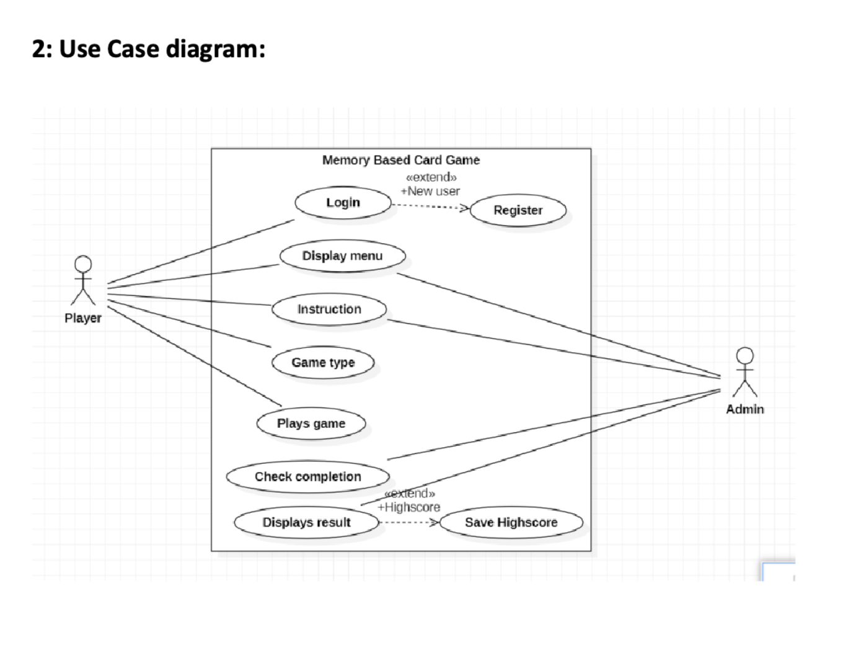

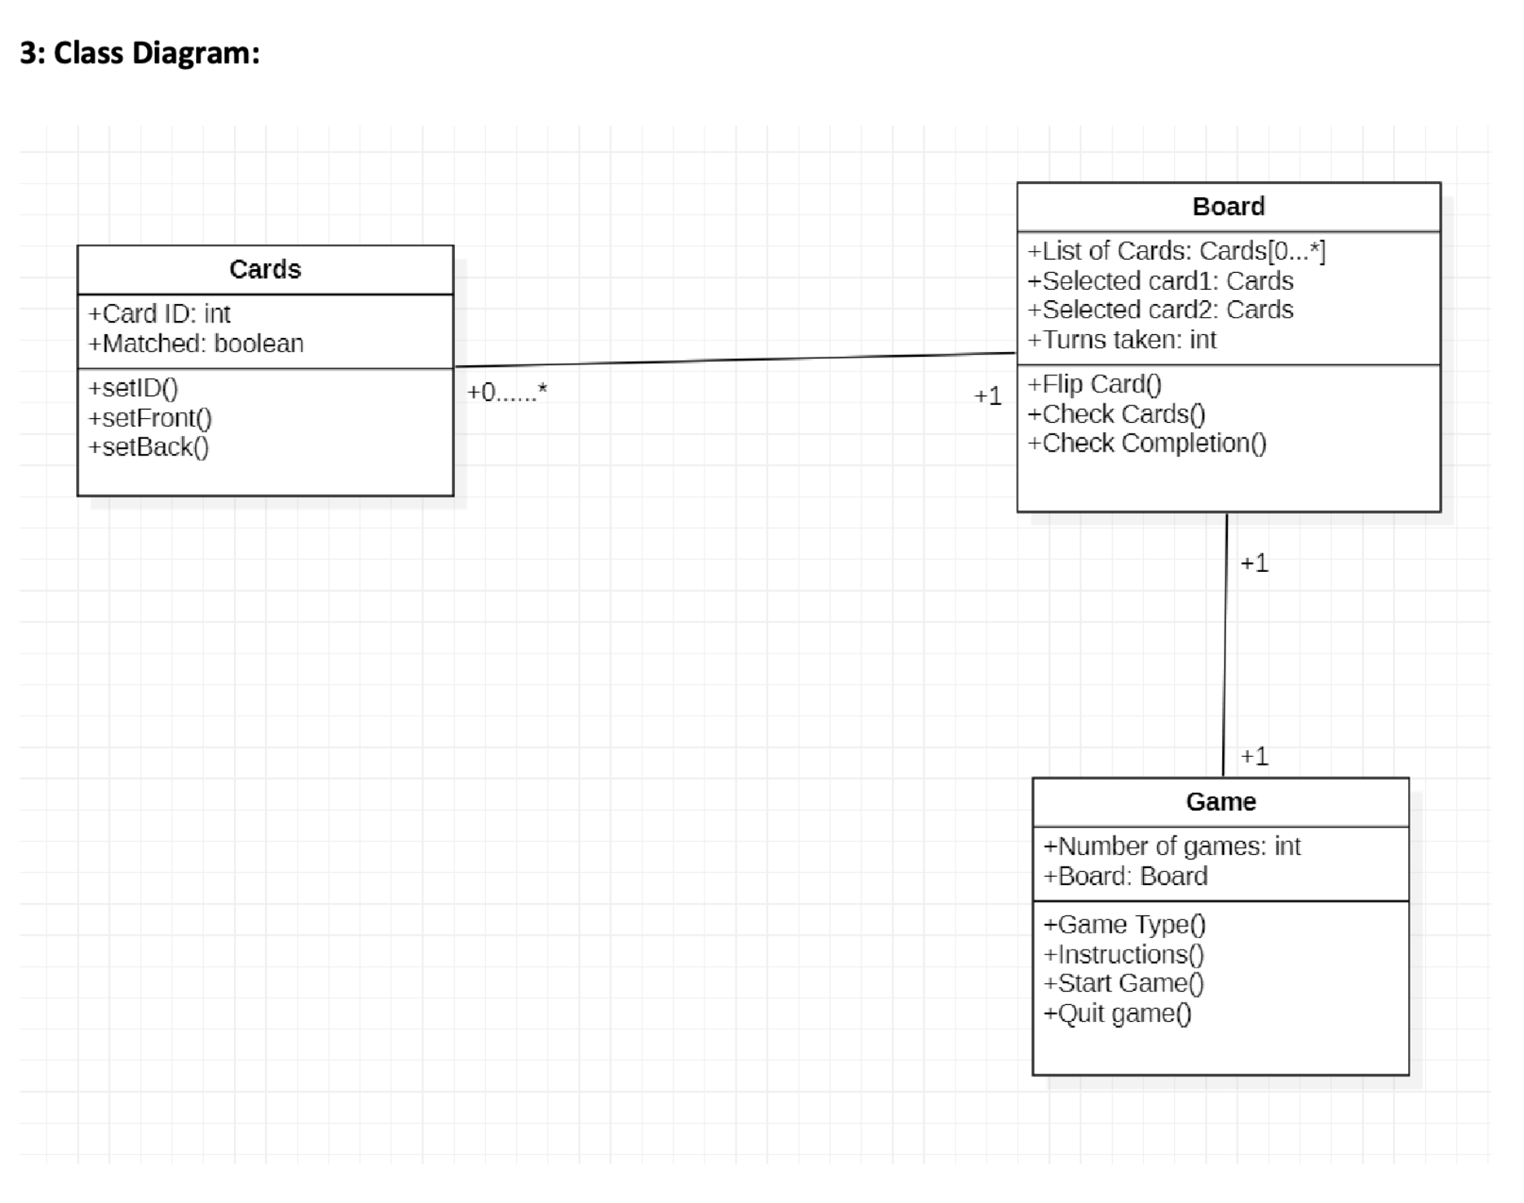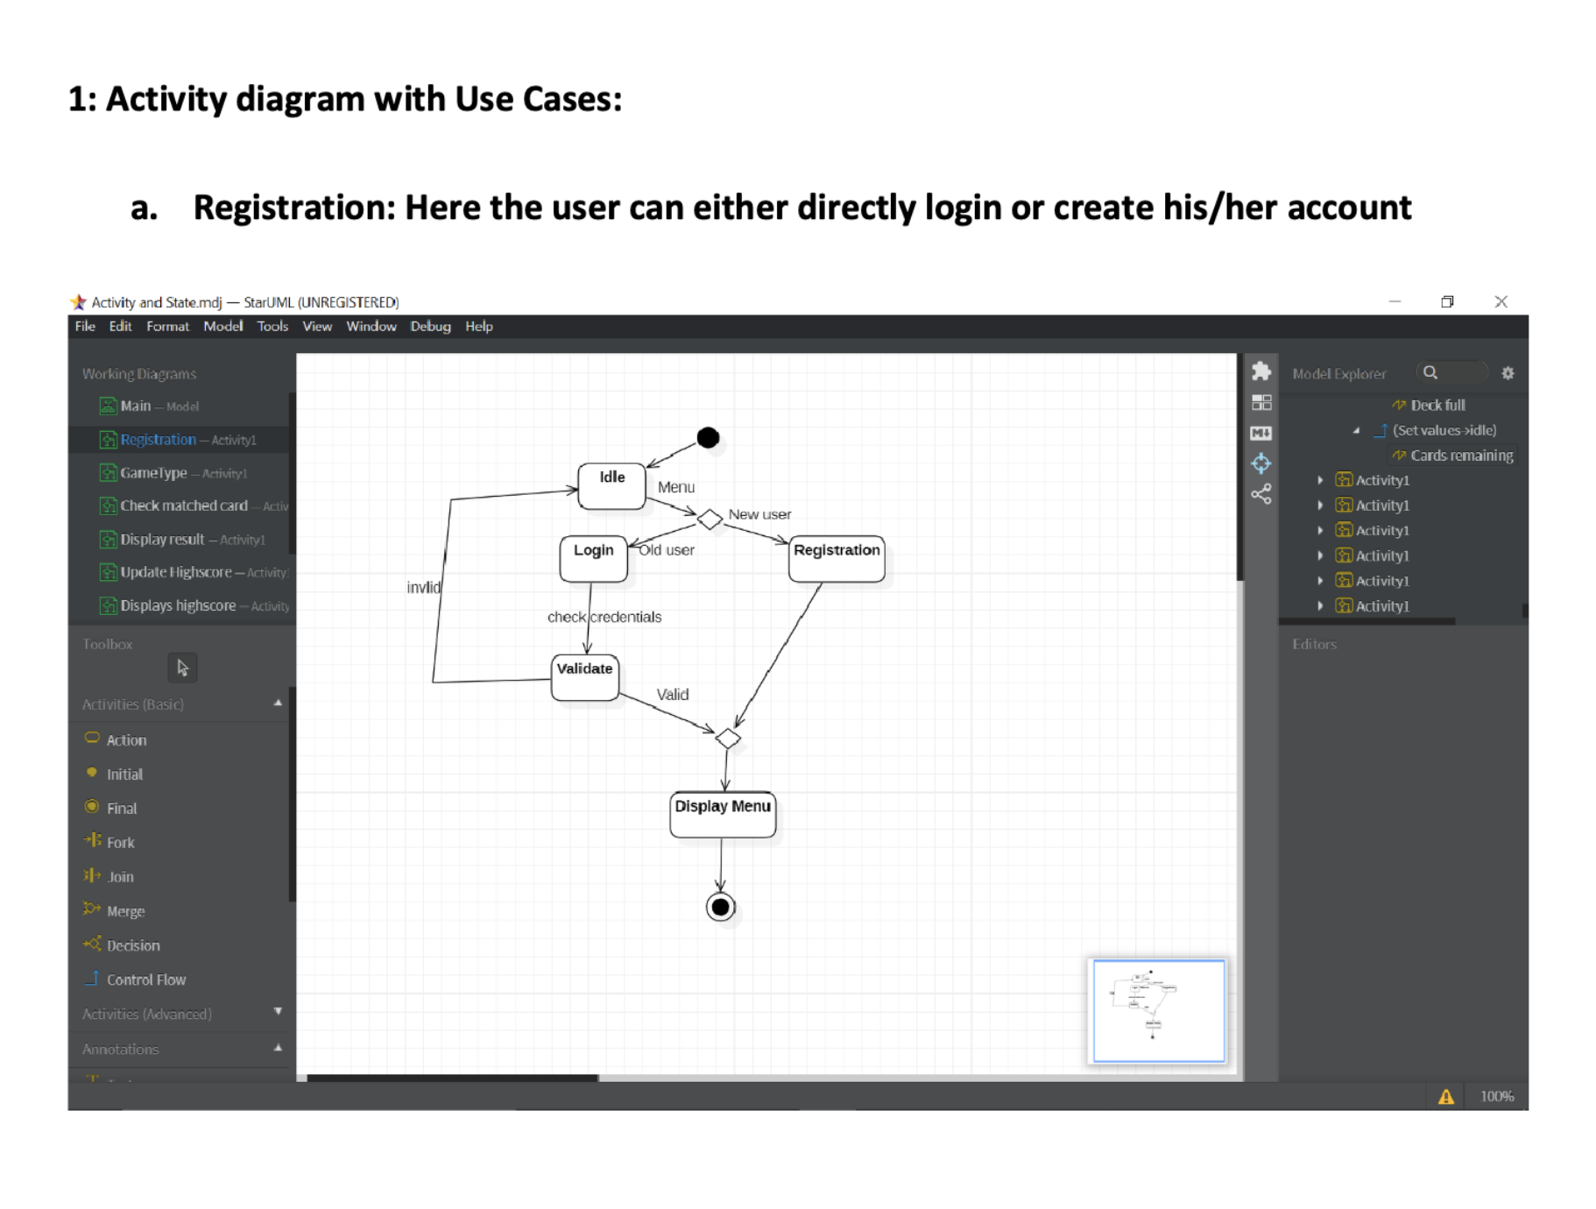

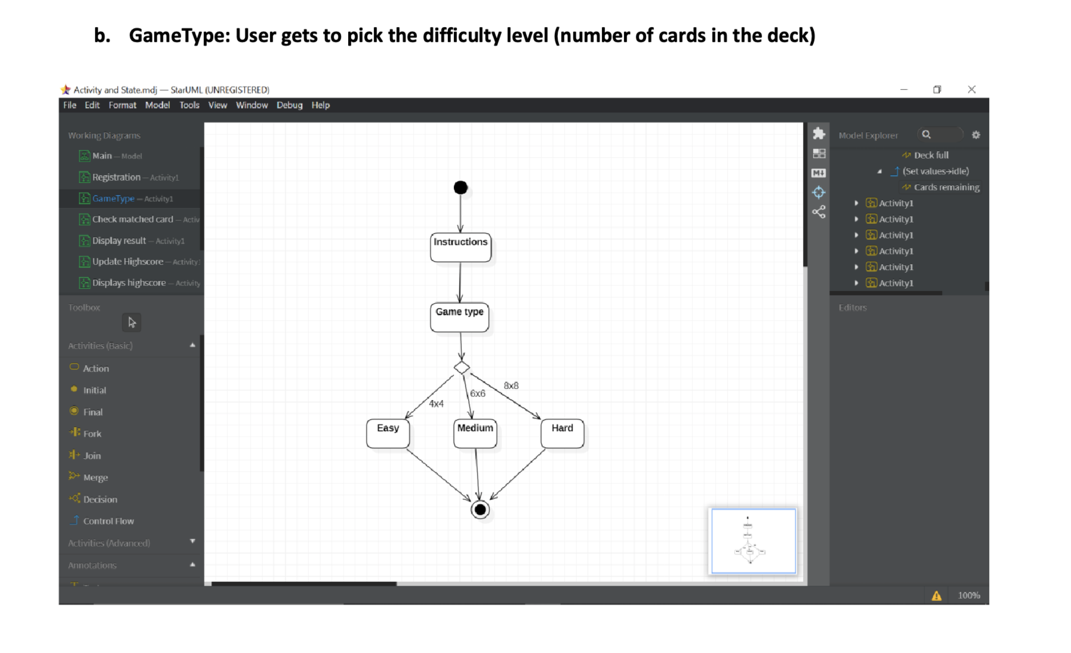

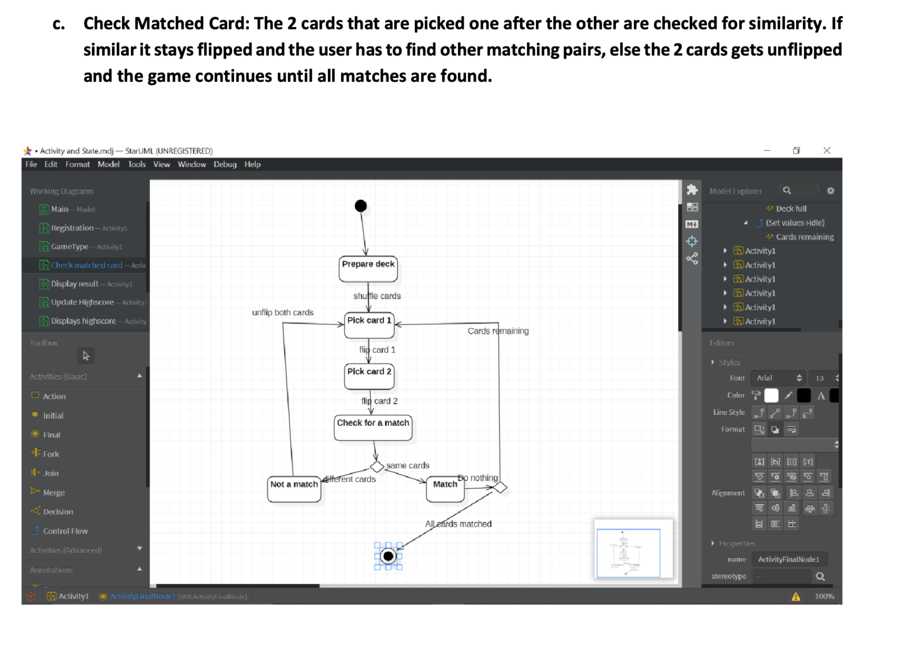

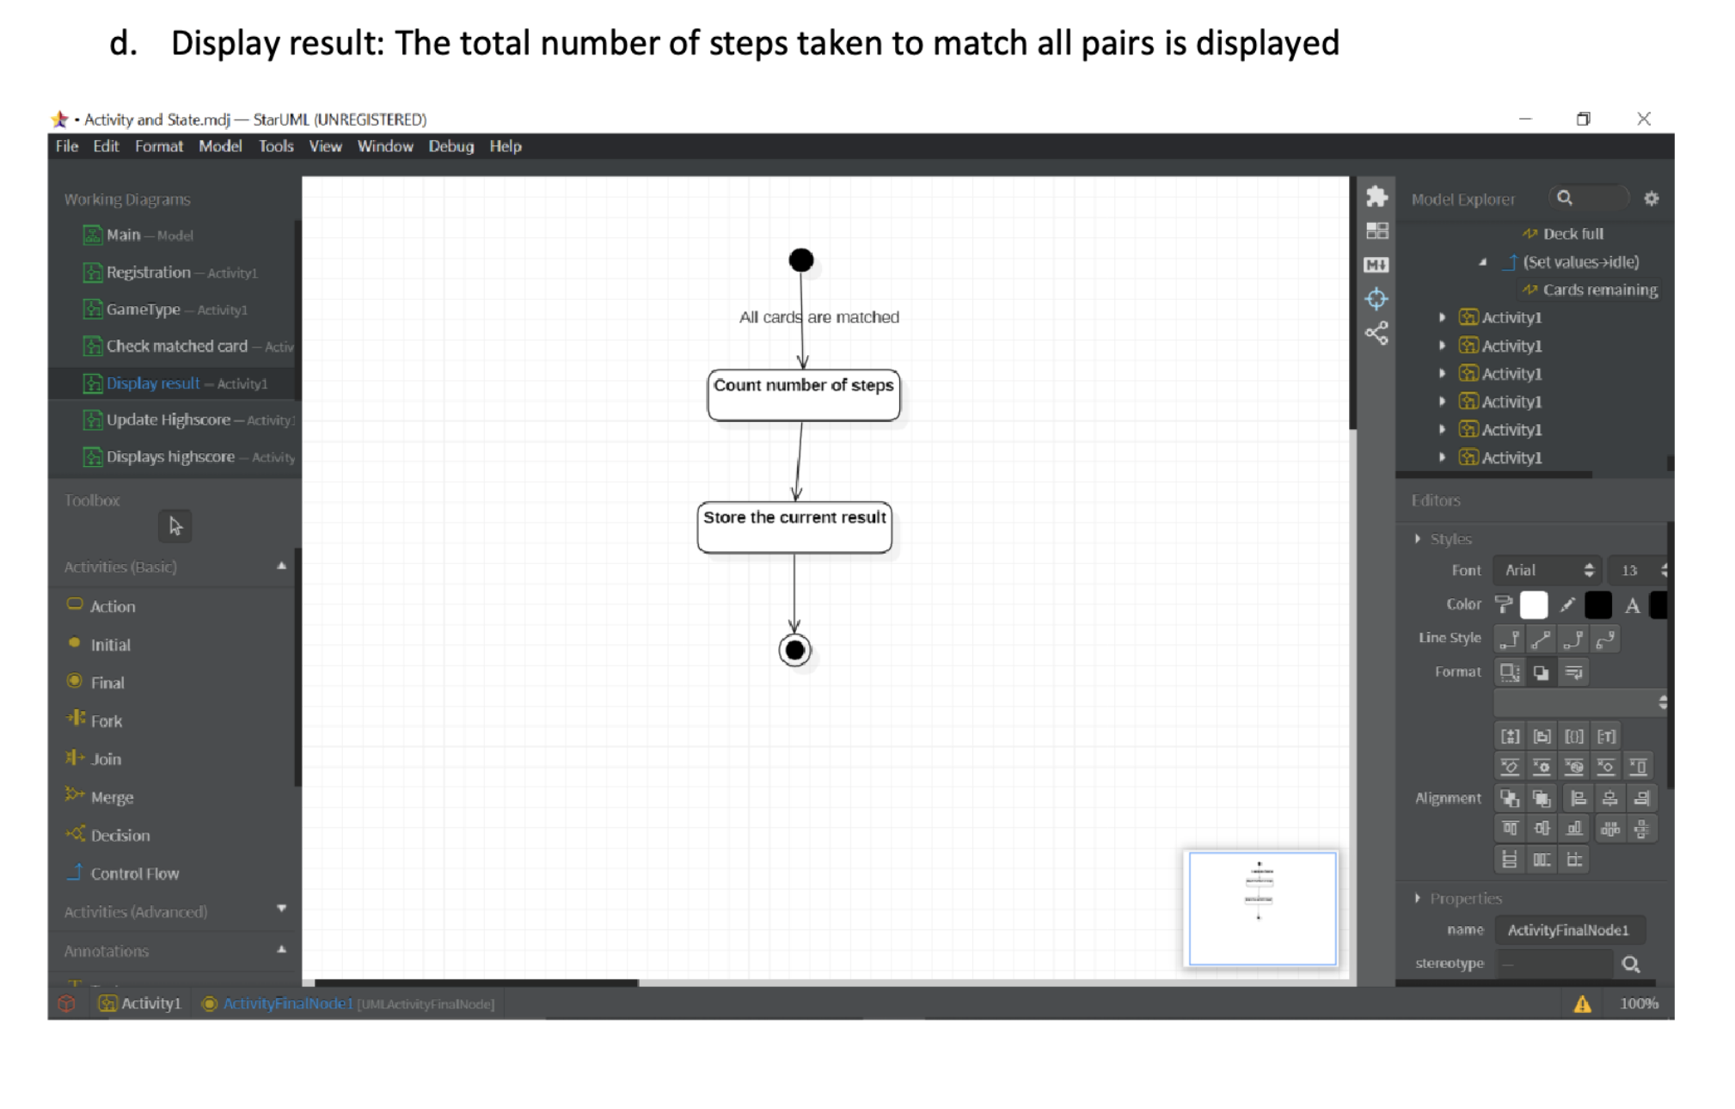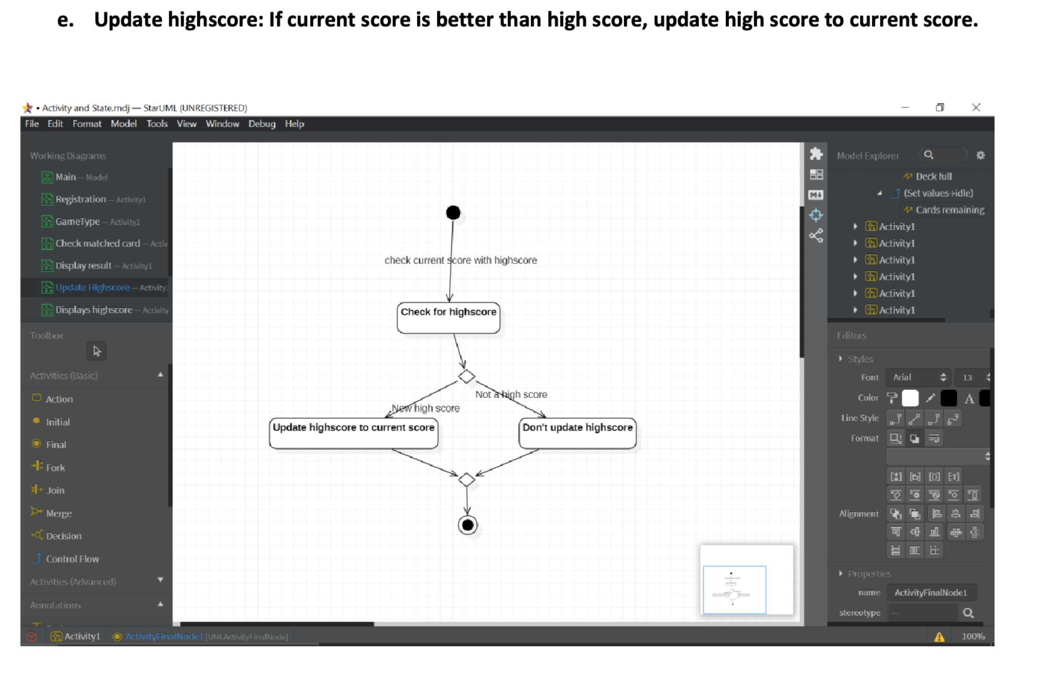

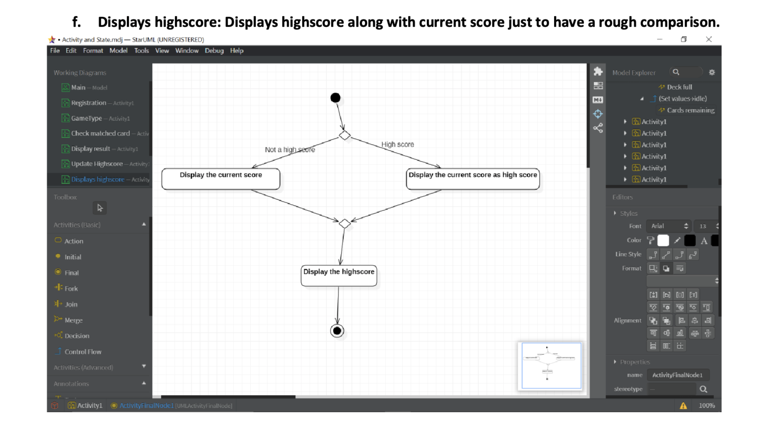

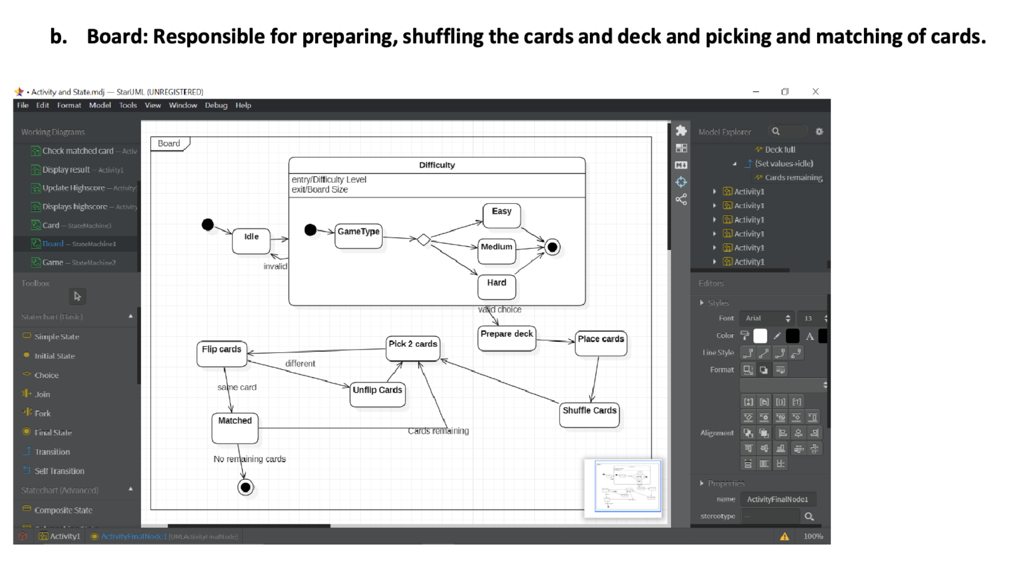



1. **Tools and Frameworks Used**

* **SwingUI**
* **Java.util**
* **Java.awt**
* **MVC**
* **vscode**

1. **Design Principles and Design Patterns Applied**

* **Design Patterns :**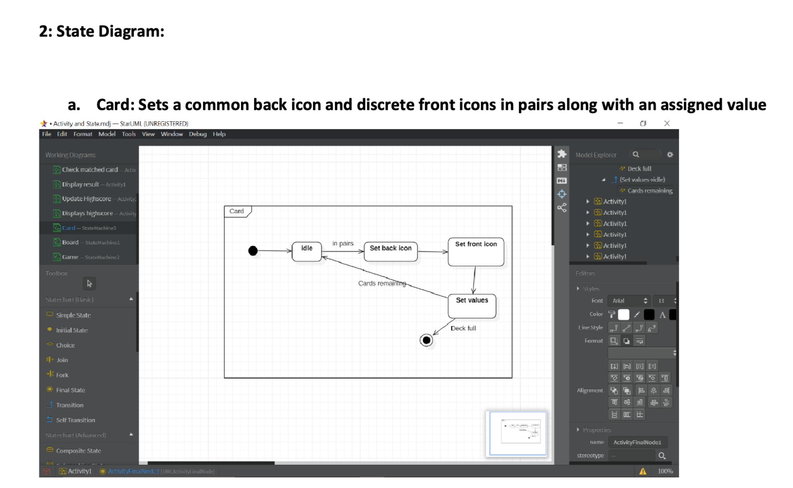
* **Singleton : only one instance of the board class is created.**
* **Composite: Game class is composed of a hierarchy of classes board and card.**

**Design Principles :**

* **Single Responsibility Principle : card class is only responsible for cards on the board**

1. **Application Screenshots (3-4 important pages)**

|  |  |
| --- | --- |
| **Teammate** | **Contribution** |
| **Mayuravarsha P (PES2UG19CS225)** | Creating the card class and UML |
| **Vaibhav S**  **(PES1UG19CS555)** | Creating the game and board class and UML |
| **Tushar Kalaskar (PES1UG19CS543)** | Creating the card class and UML |

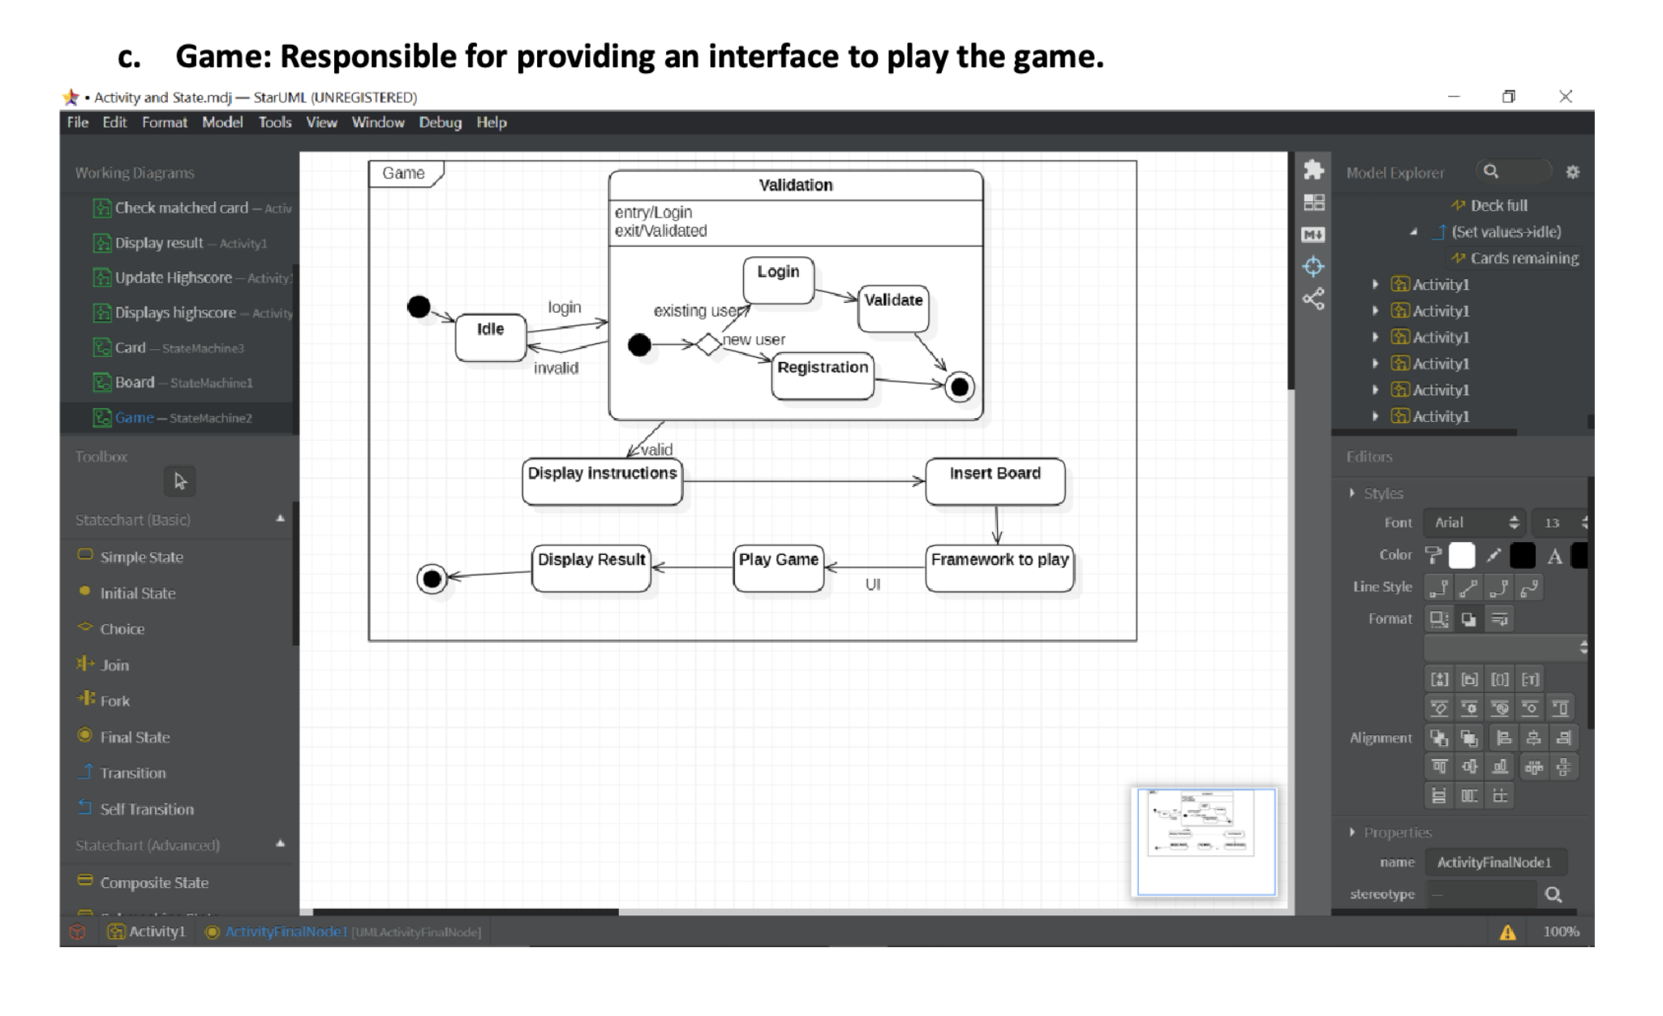

1. **Team member contributions**

**<<Table containing contributions of each team member>>**